**DAPOM report**

**Mats Kok (S5197406), Joost Oving (S5251370)**

**Executive Summary**

This report presents an analysis of the Energy Management System optimization model. By adjusting four key parameters – solar capacity, grid capacity, truck charging power, and SOC targets – we aim to find optimal configurations that increase efficiency and reduce costs. The analysis finds that keeping the existing solar capacity provides the best economic return. Reducing the grid connection below 400 kW increases the average missed State of Charge target, while increasing it above 535 kW has no further benefit. Decreasing charging power increases operational costs, mainly because of high penalties for missing the SoC target. Increasing the SoC target disproportionately increases the total cost.

1. **Solar Capacity Expansion**

One way to increase savings is by experimenting with expanding the current 1.5 MW solar installation. For this analysis, the program scales solar production using multipliers while accounting for operational savings.

The program utilizes multiplier values of 1.0, 1.2, 1.5, 2.0, 2.5, 3.0 to stimulate the expansion of the solar panel grid. A new dataset is created in each iteration, where the new solar capacity is equal to the old solar capacity multiplied by the respective multiplier. After which, the model computes the total operating costs and installation costs. In order to examine the return of the investment, the reduction in operating costs is compared to the installation costs of €1250 per added kW. Whenever this reduction in operating expenses is higher than the total installation costs, the return on the investment is positive and could contribute to the economic viability of the facility.

**Table 1: Investment and savings for multiplier**

|  |  |  |  |
| --- | --- | --- | --- |
| **Multiplier** | **Added Capacity** | **Investment** | **Operational Savings** |
| 1.0 | 0 | 0 | 0 |
| 1.2 | 300 kW | €375,000 | €45,000 |
| 1.5 | 750 kW | €937,500 | €92,000 |
| 2.0 | 1,500 kW | €1,875,000 | €135,000 |
| 2.5 | 2,250 kW | €2,812,500 | €150,000 |
| 3.0 | 3,000 kW | €3,750,000 | €157,000 |

The analysis reveals a clear optimal production at 1.5 MW solar capacity (multiplier 1.0), where the operational savings ≥ investment. This is due to the high cost of installing new solar panels (€1,250 per kW) and the relative low decrease in operational costs.

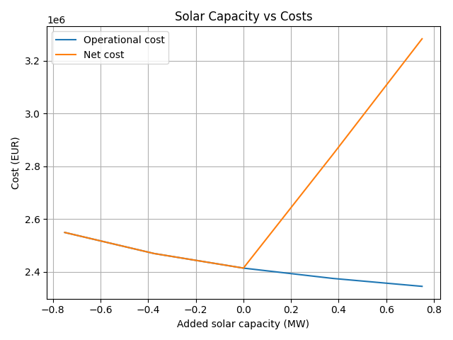**Figure 1: Solar Capacity versus Costs**

As to be expected, figure 1 shows that installation costs (equal to the difference between operational cost and net cost) are zero when no solar capacity is added. However, after 0.0, net costs rise linearly at a rate of €1,250 per added kW. Operational costs continue to decrease as solar capacity is expanded, but the rate of savings gradually diminishes: Additional kW’s of solar power yield smaller marginal reductions in operating expenses. Adding 750 kW of solar power in the current situation results in operational savings of €92,000, whereas adding another 750 kW (1500 kW in total) only increases savings by €43,000. Note that installation costs are the same for either expansion, despite the difference in returns.

We recommend to retain the current solar capacity, as the investments outweigh the reduction in operating expenses. Increasing solar capacity can reduce costs by delivering power when electricity prices are high, however, the installation costs are too high to make this expansion economically viable.

1. **Solar Capacity Adjustments**

For the following experiment, we fix the amount of solar capacity installed (1.5 MW). We are now interested in the effects of adjusting the grid connection capacity on the missed state of charge of the truck on average.

The model alters the current capacity of the grid connection and calculates the (average) missed state of charge (SoC) target and calculates this number as a percentage of the target. The model considers both higher as well as lower grid connections compared to the current capacity of 535 kW. We experiment with capacities of 225, 250, 300, 350, 400, 450, 500, 535, 600, 650, 700 kW, where 535 kW serves as the base situation. The results of this experiment are shown in table 2.

**Table 2: Grid Capacity and Missed SoC**

|  |  |  |
| --- | --- | --- |
| **Grid Capacity** | **kWh Short of Target** | **Fraction Short of Target** |
| 225 kW | 38.11 kWh | 11.91% |
| 250 kW | 33.98 kWh | 10.62% |
| 300 kW | 7.84 kWh | 2.45% |
| 350 kW | 4.25 kWh | 1.33% |
| 400 kW | 4.17 kWh | 1.30% |
| 450 kW | 4.17 kWh | 1.30% |
| 500 kW | 4.17 kWh | 1.30% |
| *535 kW* | *4.17 kWh* | *1.30%* |
| 600+ kW | 4.17 kWh | 1.30% |

The model runs a new session with each adjusted grid capacity, after which it calculates the average missed SoC over all charging sessions. It does so by first computing the total missed SoC relative to the charging target. The charging target is computed by multiplying the minimum battery capacity and the total capacity of the truck’s battery. In this case, we aim to achieve 80% SoC with a battery capacity of 400 kWh, resulting in a charging target of 320 kWh. Furthermore, the missed SoC target is given as percentage of the total charging target of the truck.

When decreasing grid capacity to 225 kW (less than half of the current capacity), we conclude that the truck’s battery is 38.11 kWh or 11.91% short of the SoC target. Gradually increasing grid capacity reveals that kWh and fraction short of target decreases, which is to be expected. We seem to reach a steady state after 400 kW, where missing SoC levels out at 4.17 kWh or 1.30%, and this number does not decrease as we further increase grid capacity. This phenomenon can also be observed in figure 2, where missing SoC is stable for grid capacities of over 400 kW.

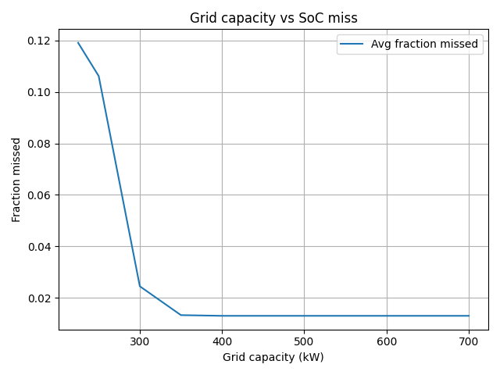**Figure 2: Fraction of SoC Target missed at Grid Capacity level**

Increasing grid connection capacity beyond the current 535 kW level does not result in decreasing levels of SoC targets missed. After around 400 kW capacity, the missed SoC levels seem to level out and are due to factors other than grid capacity. We recommend to never drop grid capacity below 400 kW, as this drastically increases missed SoC targets and the resulting fines associated with missing these targets.

1. **Charging Power versus Costs**

The next experiment tests what effect different charging rates of the truck has on total operational costs. When energy costs are low, the truck could charge faster to make better use of these lower prices. Similarly, when prices are high, the truck is able to discharge faster to the grid and reduce energy costs.

The program modifies the current charging power of the truck (max 100 kW charge or discharge) and prompts the total operational costs associated with the new charging power. The model test this connection with 20, 50, 75, 100, 125, 150, 200 kW charging or discharging power, where 100 kW serves as the benchmark. The results are provided in table 3.

**Table 3: Charging Power and Costs with Penalty = 1000**

|  |  |  |
| --- | --- | --- |
| **Charging Power** | **Operational Costs** | **Change compared to 100 kW** |
| 20 kW | €117.275.118,59 | + 4757% |
| 50 kW | €39.581.553,06 | + 1539% |
| 75 kW | €12.884.811,94 | + 433% |
| 100 kW | €2.414.235,92 | + 0% |
| 125 kW | €132.190,44 | - 94% |
| 150 kW | €129.837,50 | - 95% |
| 200 kW | €126.021,13 | - 95% |

Table 3 shows the results for a penalty cost of €1000 for missed SoC target. As charging power decreases, the possibility of missing the SoC target becomes much bigger. Missing these targets increases total costs disproportionately, as the fine for missing SoC target are high. With a charging power of 20 kW, total operational costs rise to over €117 million. As this is not a feasible result, we experiment with lowering the fine for missing SoC target. Table 4 shows the result for the same charging powers, but now the fine is set at a more reasonable €10.

|  |  |  |
| --- | --- | --- |
| **Charging Power** | **Operational Costs** | **Change compared to 100 kW** |
| 20 kW | €1.286.718,59 | + 719% |
| 50 kW | €526.053,06 | + 235% |
| 75 kW | €262.311,94 | + 67% |
| 100 kW | €157.035,92 | + 0% |
| 125 kW | €132.190,44 | - 16% |
| 150 kW | €129.837,50 | - 17% |
| 200 kW | €126.021,13 | - 20% |

**Table 4: Charging Power and Costs with Penalty = 10**

Operational costs still increase as charging power decreases, but now at a more sensible rate due to the lower fine for missing SoC target. Cutting current charging power in two results in 235% higher operational cost. This suggests that decreasing charging power disproportionately increases operational costs. On the other hand, doubling charging power only leads to a 20% decrease in operational costs. In order to make the investment economically viable, the savings in operational cost should outweigh the cost of installation of the faster charging equipment.

Decreasing charging power increases operational costs at a highly non-linear fashion, mostly due to the high penalty costs for missing SoC target. Lowering this penalty decreases the rate at which operational cost rises, however, operational cost still tend to drastically increase. Decreasing charging power is generally never worth it, and increasing charging power only makes sense if the benefits of lower operational costs offset the investment in faster charging equipment.

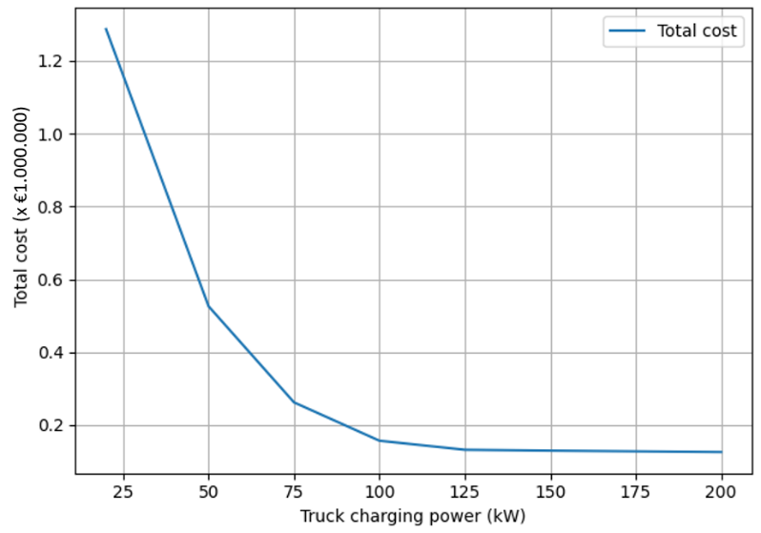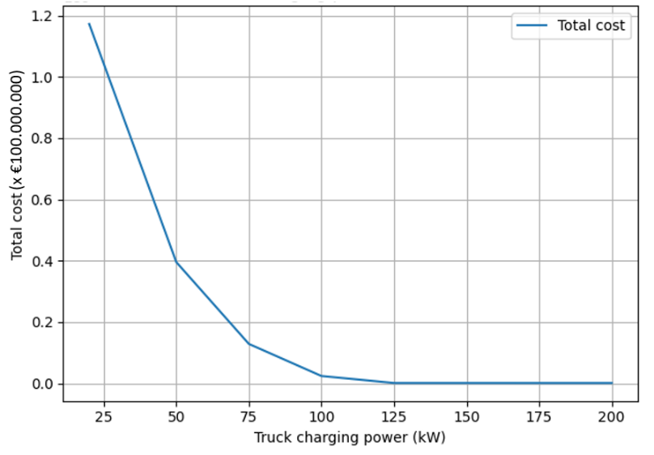**Figure 3: Costs and Charging Power for Penalty 1000 & 10, respectively**

1. **Varying SoC Target**

Finally, this last experiment will test the effect of changing the state of charge (SoC) target on total energy costs. Allowing trucks to leave with less or more battery capacity will effect the total energy costs by means of the average price of electricity and the penalty costs for missing this target.

The experiment uses SoC targets up to 100% of the truck’s capacity of 400 kWh. More specifically, we consider 60%, 70%, 80%, 90%, and 100%, with 80% performing as the benchmark target. The program replaces the existing SoC target with the new one and computes the new total energy consumption. These results are showcased in table 5.

|  |  |  |
| --- | --- | --- |
| **SoC Target** | **Total Costs** | **Costs per Session** |
| 60% | €123.911,93 | €226,53 |
| 70% | €129.286,55 | €236,36 |
| 80% | €2.414.235,92 | €4.413,59 |
| 90% | €6.978.759,88 | €12.758,24 |
| 100% | €11.543.314,59 | €21.102,95 |

**Table 5: SoC Targets and their Total Costs with Penalty = 1000**

|  |  |  |
| --- | --- | --- |
| **SoC Target** | **Total Costs** | **Costs per Session** |
| 60% | €123.911,93 | €226,53 |
| 70% | €129.286,55 | €236,36 |
| 80% | €157.035,92 | €287,09 |
| 90% | €207.159,88 | €378,72 |
| 100% | €257.314,59 | €470,41 |

**Table 6: SoC Targets and their Total Costs with Penalty = 10**

Once again, the total costs are increasing non-linearly with SoC target when the penalty is set at €1000. Due to the higher target, the chance of not meeting this target becomes larger. This means that the facility has to pay more penalties, ultimately leading to total costs of over €11.000.000 when adopting the 100% charge target. The cost per session would rise to an unreasonable €21.102,95. However, if we dropped the penalty to €10 for missing the SoC target (just like in experiment 3), we see that total costs rise at a more reasonable rate. The same intuition applies: The higher the SoC target, the higher the chance for missing the target, the higher the penalty costs will be. Due to lowering the penalty, the cost per session will only be €470,41 as opposed to €21.102,95. As figure 4 shows, there is a positive relationship between SoC target and total costs. The rate at which total costs rises is mainly due to the height of the penalty cost.

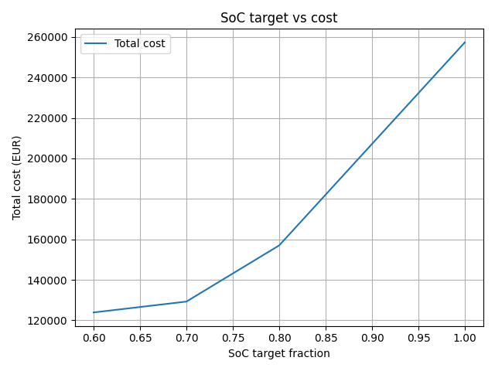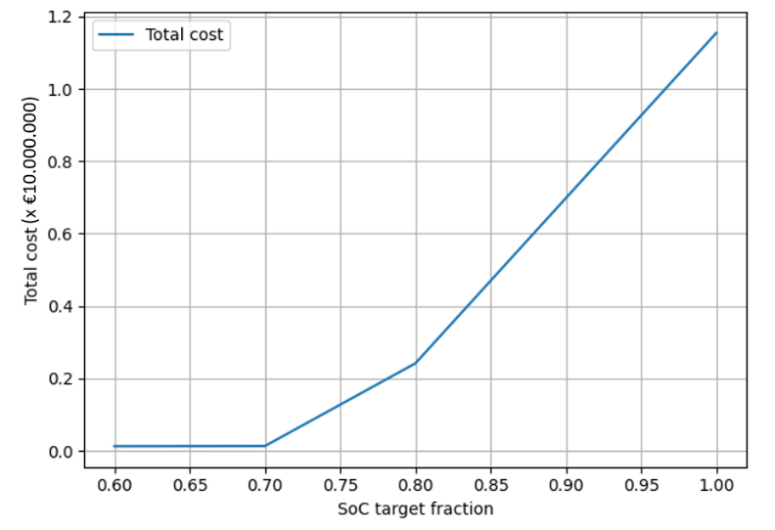**Figure 4: Total Costs with SoC Target and Penalty of 1000 & 10, respectively**

Lowering SoC target will reduce the total costs, as penalties for missing this target will be less likely. Increasing SoC targets will disproportionately increase total costs, leading to extremely high costs per session. The tradeoff in this experiment is achieving lower operating costs at the expense of less fully charged trucks.